**ASSIGNMENT HELP**

**MANUAL**



SUBMITTED

TO

VISHWAKARMA INSTITUTE OF INFORMATION TECHNOLOGY, PUNE

FOR THE SKILL AND COMPETENCY EVALUATION OF

ARTIFICIAL INTELLIGENCE [CAUA31201]

IN

**CSE AI DEPARTMENT**

BY

**Vedant Rakesh Mukhekar**

**Class: T.Y. BTech Division: A Batch: A2**

**Batch Teacher**

**Dr. ANURADHA YENKIKAR.**

**INDEX**

|  |  |  |
| --- | --- | --- |
| **SR. NO.** | **CONTENTS** | **PAGE NO.** |
| **1** | **PROBLEM STATEMENT** | **4-5** |
| **2** | **LIBRARY USED** | **5-6** |
| **3** | **THEORY** | **6-7** |
| **4** | **METHODOLOGY** | **7-14** |
| **5** | **ADVANTAGES & DISADVANTAGES** | **14-15** |
| **6** | **WORKING** | **16-17** |
| **7** | **DIAGRAM** | **17-18** |
| **8** | **CONCLUSION** | **18-19** |

### Problem Statement

The **Backward Chaining Algorithm** is an inference technique used in artificial intelligence, particularly in rule-based expert systems. The objective of this algorithm is to determine if a specific conclusion (goal) can be inferred from a set of known facts and rules. The algorithm starts with the goal and works backward to find the facts that support it, making it particularly useful in situations where the goal is known, but the underlying facts are not.

This implementation aims to demonstrate the Backward Chaining Algorithm through a simple example involving a knowledge base of facts and rules. The goal is to determine whether a specific conclusion can be derived by recursively checking the necessary conditions until all supporting facts are found or deemed unprovable.

### Libraries Used

* **Python Standard Libraries**:
  + No external libraries are required for the basic implementation.

### Theory

Backward chaining is a reasoning method used in artificial intelligence (AI) that involves starting with a goal and working backward to determine what facts must be true to support that goal. It is commonly used in expert systems, especially in applications that require decision-making based on a specific target or outcome.

#### Key Concepts

* **Knowledge Base**:
  + The knowledge base contains a set of facts and rules.
  + **Facts** are assertions about the world that are known to be true.
  + **Rules** are conditional statements formulated as "if-then" statements, where the "if" part (premise) specifies the conditions for the rule's application, and the "then" part (consequent) indicates what can be inferred if the conditions are met.
* **Inference**:
  + The process of deriving new information based on existing knowledge and rules.
  + Backward chaining involves asking if a specific conclusion can be reached, and if so, determining the facts required to support that conclusion.
* **Recursive Approach**:
  + Backward chaining uses a recursive approach to check whether the necessary conditions for a goal are satisfied. If a condition is itself a goal, the algorithm checks for its fulfillment in the same manner.

#### Process of Backward Chaining

1. **Initialization**:
   * The algorithm starts with a specified goal (the conclusion to prove).
2. **Rule Evaluation**:
   * It examines the rules in the knowledge base to identify rules whose conclusions match the goal.
3. **Condition Check**:
   * For each applicable rule, it checks whether the conditions (premises) are satisfied.
   * If the conditions are not satisfied, the algorithm recursively calls itself for each condition to determine if they can be proven from known facts or other rules.
4. **Conclusion**:
   * If all conditions for the goal are satisfied, the goal is considered proven. If any condition cannot be satisfied, the goal cannot be proven.

#### Applications

Backward chaining is widely used in various domains, including:

* **Expert Systems**: To provide explanations and reasoning in fields such as medical diagnosis, troubleshooting, and legal reasoning.
* **Game AI**: In applications where decisions are based on specific outcomes or strategies.
* **Automated Planning**: To identify steps needed to achieve a specific goal in robotics and logistics.

### Methodology

1. **Define the Knowledge Base**: Create a list of facts and a set of rules in the form of condition-consequence pairs.
2. **Implement the Backward Chaining Algorithm**:
   * Start with the specified goal.
   * Check each rule to see if it can lead to the goal.
   * Recursively check if the conditions of the applicable rules can be satisfied.
3. **Determine the Conclusion**: Continue the process until the goal is proven or determined to be unprovable.

### Advantages & Disadvantages

* **Advantages**:
  + Backward chaining is efficient in cases where the goal is known, as it avoids unnecessary evaluations of facts.
  + It is particularly effective in scenarios with a clear goal and well-defined rules.
* **Disadvantages**:
  + It can become inefficient if the number of rules and facts is large, especially if many rules have overlapping conditions.
  + If the knowledge base is incomplete, the algorithm may not be able to reach a conclusion, even if it is logically valid.

### Working Example (Python Code)

Here's a simple implementation of the Backward Chaining Algorithm:

python

Copy code

# Define the knowledge base as a set of rules and facts

class BackwardChaining:

def __init__(self):

self.facts = set() # Initialize known facts

self.rules = [] # Initialize rules

def add_fact(self, fact):

self.facts.add(fact) # Add a new fact

def add_rule(self, rule):

self.rules.append(rule) # Add a new rule

def backward_chain(self, goal):

# If the goal is already a known fact

if goal in self.facts:

return True

# Check each rule to see if it can lead to the goal

for rule in self.rules:

if rule['consequent'] == goal:

# Check if all conditions of the rule are satisfied

if all(self.backward_chain(condition) for condition in rule['conditions']):

return True

return False # Goal cannot be proven

# Example Usage

if __name__ == "__main__":

# Create an instance of the Backward Chaining algorithm

bc = BackwardChaining()

# Define initial facts

bc.add_fact("A")

bc.add_fact("B")

# Define rules

bc.add_rule({'conditions': ["A"], 'consequent': "C"})

bc.add_rule({'conditions': ["B"], 'consequent': "D"})

bc.add_rule({'conditions': ["C", "D"], 'consequent': "E"})

# Set the goal to be inferred

goal = "E"

# Run the backward chaining process

if bc.backward_chain(goal):

print(f"Goal '{goal}' can be proven.")

else:

print(f"Goal '{goal}' cannot be proven.")

### Diagram

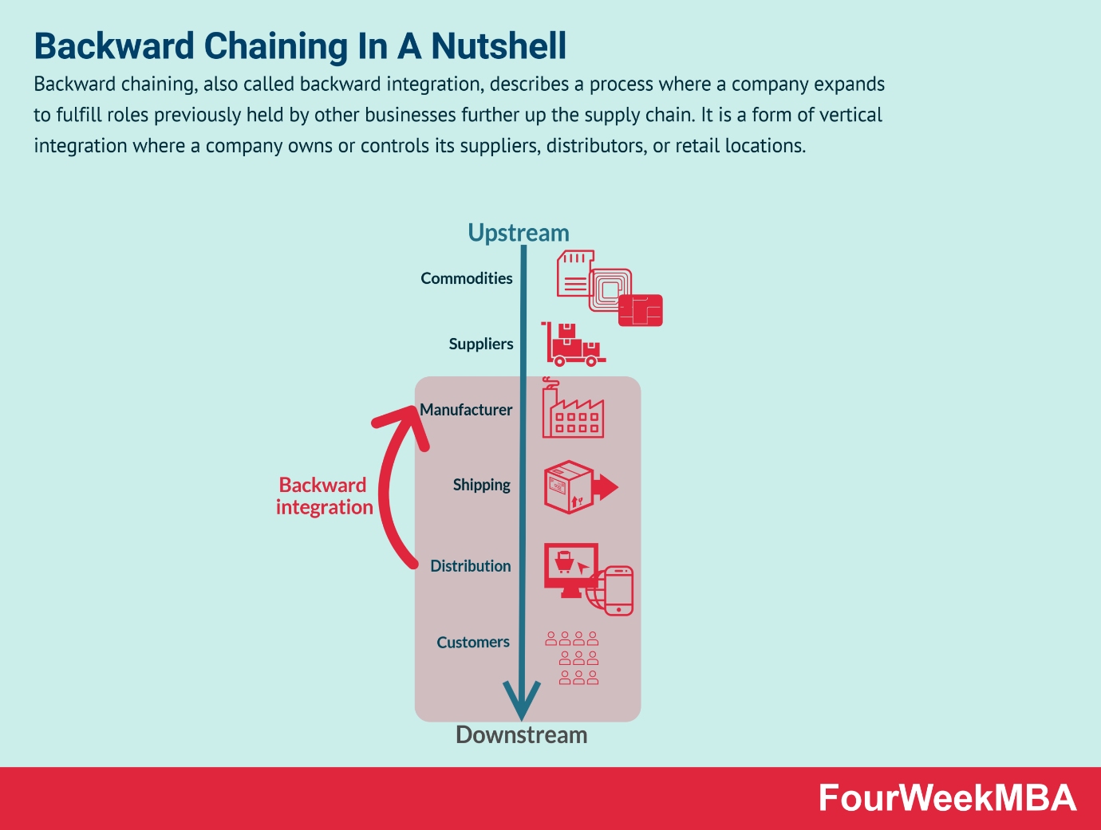

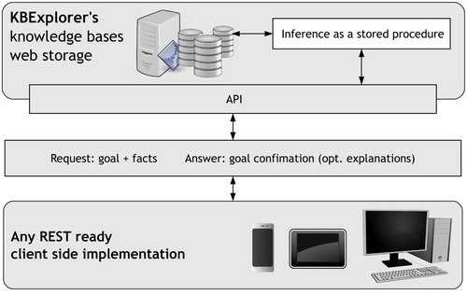

### Conclusion

The **Backward Chaining Algorithm** is a powerful technique for deriving conclusions from a set of known facts and rules in artificial intelligence. This implementation demonstrates its utility in rule-based systems and shows how it can be used to prove a specific goal by recursively checking the conditions that support it. Backward chaining's efficiency in goal-directed reasoning makes it an essential tool for various applications in AI, particularly in expert systems where the outcome is predetermined, and supporting knowledge needs to be identified.